

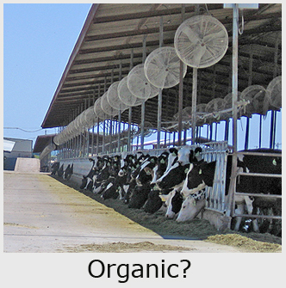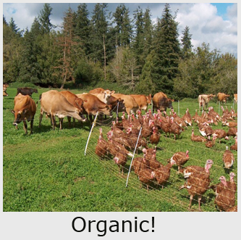

ACTION ALERT

Proposed USDA Rule Could Shut Down Organic Family Farmers

Consumers and Farmers Join Together to Rein in Factory Farms and
Protect the Livelihoods of Ethical Farm Families

Since the organic community first appealed to the USDA for better clarification and enforcement of regulations requiring organic dairy producers to graze their cattle, nearly 9 years ago, the number of giant industrial dairy operations, with as many as 10,000 cows, has grown from two to approximately 15. After years of delay, the USDA has finally responded with a new proposed rule that they said would crack down on abuses.

We now estimate there are 35,000 to 45,000 cows on giant CAFOs (concentrated animal feeding operations) operating in the United States producing as much as 40% of the nation's organic milk supply—depressing prices for legitimate family farmers.

The Cornucopia Institute has filed formal legal complaints with the USDA aimed at compelling the agency to enforce organic livestock and management rules. These actions have led to the shut down or penalizing of some of what we call "organic scofflaws." But many in the industry criticize the agency for failing to fully investigate many other alleged violations on giant farms.

The new USDA rule proposal and its analysis total 26 pages, as published in the Federal Register. The draft rule complies with organic community requests to close

specific loopholes being exploited by factory farms confining their cattle. But it also represents the broadest rewrite of federal organic regulations in the $20 billion industry's relatively short history.

But, the new rules, if enacted, would put out of business the majority of organic livestock farmers—including hundreds who are operating ethically.

"At first we were delighted that the USDA had stopped their delaying tactics and finally published a rule cracking down on the large factory farms that have been ‘scamming’ organic consumers and placing ethical family farmers at a competitive disadvantage,” stated Bill Welch, former member of the National Organic Standards Board, Iowa livestock producer and VP of The Cornucopia Institute. "Many in the industry have spent the past weeks carefully examining this dense document, and it has become painfully clear that it would not only crack down on certain factory farm abuses, but it’s also so restrictive that it would likely put the majority of family farmers producing organic milk and meat out of business."

Cornucopia, the Organic Consumers Association, and some of the largest organic certifiers and other groups representing farmers and consumers are formally asking the USDA to extend the public comment period for an additional 30 days.

Major policies proposed by the USDA rule (never reviewed or recommended by the National Organic Standards Board) include:

- Eliminating the fattening of beef cattle on grain, in feedlots, for the last few months of their lives. Although many might view this proposal as meritorious, it would radically change the industry and could force some operators out of business. Full analysis and discussion by the organic community is vitally necessary.

- Requiring animals to be outside year-round, without exemptions for extreme weather conditions, would put the lives and well-being of livestock at risk and economically injure farmers.

- Setting aside part of a farmer's land in a "sacrifice" pasture for when weather conditions make grazing unsuitable. This might be a provision that some current operators cannot meet and might violate certain state and federal environmental standards. This may have positive application, but its overall impacts have never been fully analyzed. And the USDA rule outlaws barnyards, another environmental mistake.

- Classifying bees and fish as livestock will likely garner positive and negative response from that industry sector depending on its perceived present and future regulatory impact.

- The USDA draft rule ignores the NOSB recommendation to eliminate the "continual transition" of conventional cattle, brought onto organic dairy operations. The industry has universally agreed that all animals brought onto a farm, after its initial transition to organics, must be managed organically from the last third of gestation.

Animals raised for meat already have to meet this higher standard. Many industry experts feel that the USDA has misinterpreted the law, for years, allowing giant factory farms to "burn out" their cattle, ,prematurely sending them to slaughter, then replacing them with cheap conventional cattle on an ongoing basis. This new rulemaking proposes that the Department’s "misinterpretations" become institutionalized as law.

The Organic Community Needs to Join Together!

The Cornucopia Institute has joined together with the Organic Consumers Association, FOOD Farmers and a number of the nation's leading organic certifiers to collaborate and endorse an "alternative" rule that will crack down on factory farm abuses, and uphold organic integrity, without making it impossible for existing family farms to operate and survive …. please join us in endorsing this proposal!

You can find a copy of the "alternative" rule, along with the original USDA Federal Register notice containing the USDA draft proposal, on the Cornucopia website at: www.cornucopia.org. Click on the "Projects" tab and choose "pasture/livestock rulemaking."

(NOTE: If you are one of our Amish members, or someone else without internet access, please call us at 608-625-2042 and we will immediately mail you out an information package.)

You need to act ….. now!
Public comments are due in Washington by December 23

Please make your voice heard. We need to come together as a community to send a strong, unified message to the USDA. If we don't succeed in building an overwhelming coalition of farmers, consumers, retailers and ethical businesses joining together, the USDA bureaucrats in Washington will feel they can do whatever they think is "best." In the past their performance has been troubling.

Please customize the enclosed letter and mail it back to the USDA …. ASAP!

MAIL: In addition to the enclosed form letter, a Microsoft Word version of this letter is also posted on the projects page of the Cornucopia website so you can download it and customize it at your discretion. Original and custom letters will hold even higher weight than the form letter. Hand written notes are powerful!

INTERNET: We find it a rather cumbersome system but you can also, especially if time is tight, transmit your message to the USDA via their website. You can even download our standard letter off of the Cornucopia website, customize it, and paste it into the USDA’s message system. Visit the Regulations web portal: www.regulations.gov. Use the search terms “organic pasture.” Do not leave it to the last moment to submit comments as the USDA website tends to get overloaded at the end of comment periods.

